**Leaning Tower of Pisa, Italy**

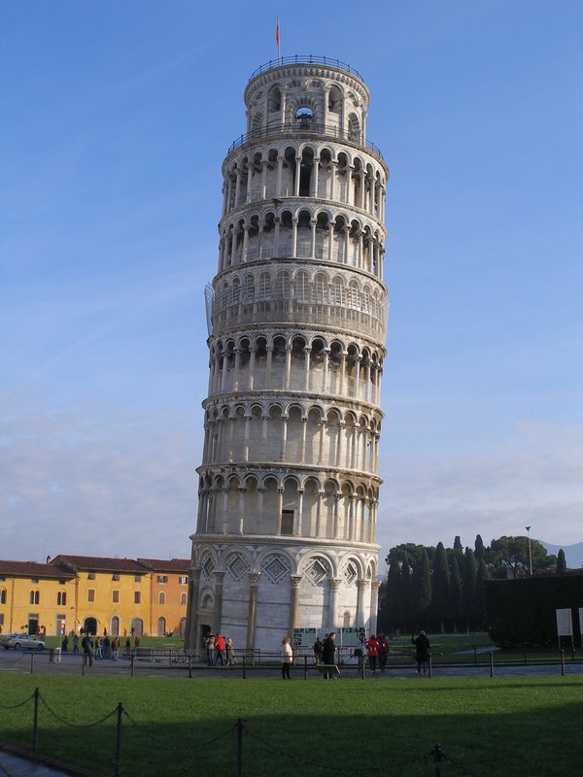

Leaning Tower of Pisa is a unique structure, leaned at one side. It is campanile in the Italian city of Pisa.

The Tower is 56.70 high, 4.09m wide and leaned at 3.99 degrees.The construction of the tower started in 1173 and was completed in 1372. The tower has eight stories, including chamber of bells. It was not planned originally as a something like this, but during the construction it started leaning, and today although it weighs more than 14,000 metric tons, miraculously and proudly stands as one of the most beautiful structures of the world.